# AWS ec2 services

1. Launch one ec2 using Amazon Linux 2 image and add script in user data to install Apache.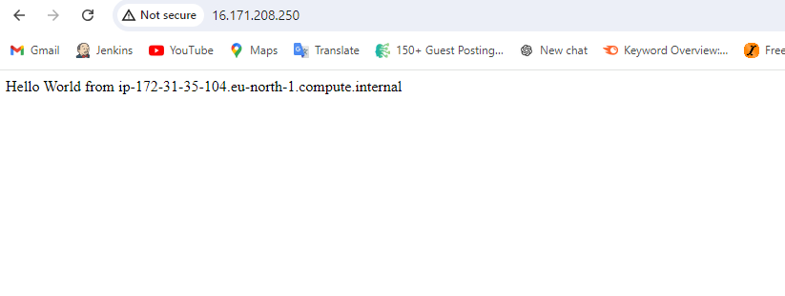
2. Launch one ec2 using Ubuntu image and add script in user data to install Nginx.
   1. 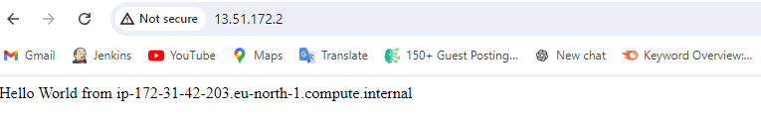
3. Take snapshot of the instances created in Task 1.
   1. 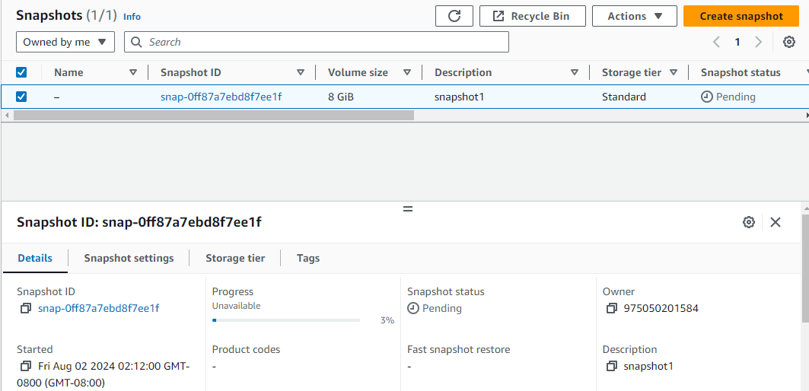
4. Enable Termination policy on ec2 created in Task 2.

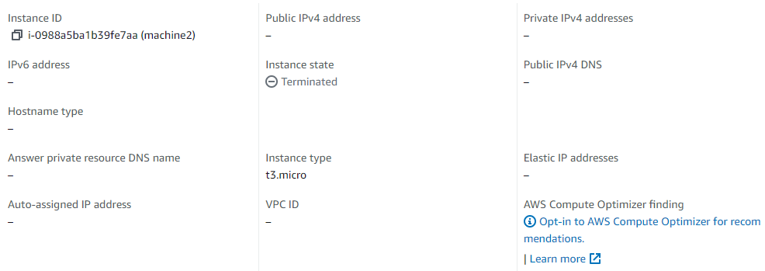

1. Launch any ec2 using spot purchasing option.

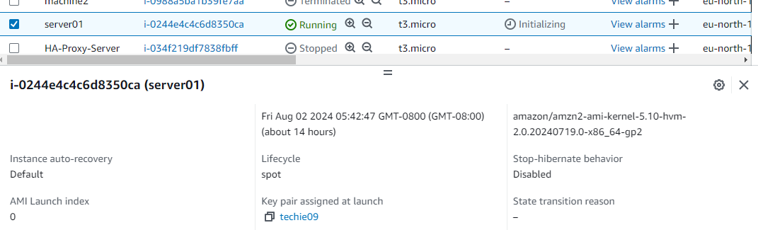

1. Launch one ec2 using Aws CLI.

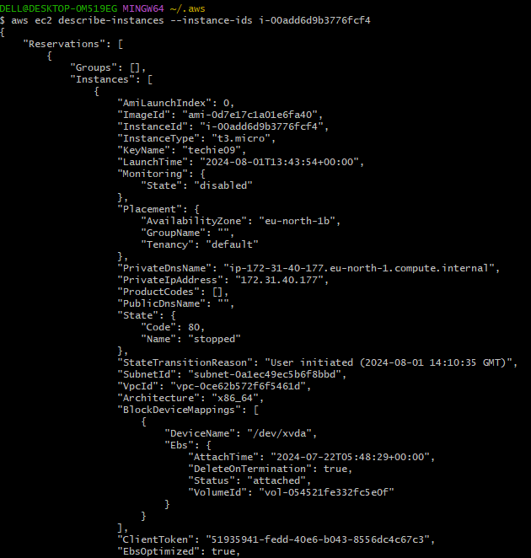

1. Assign password less authentication for ec2 created on Task 2.

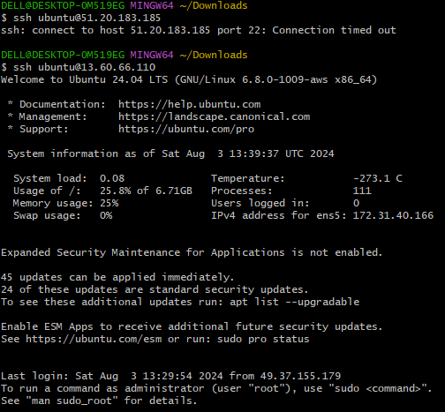

1. Install Apache Tomcat in private ec2 and deploy a sample app.

